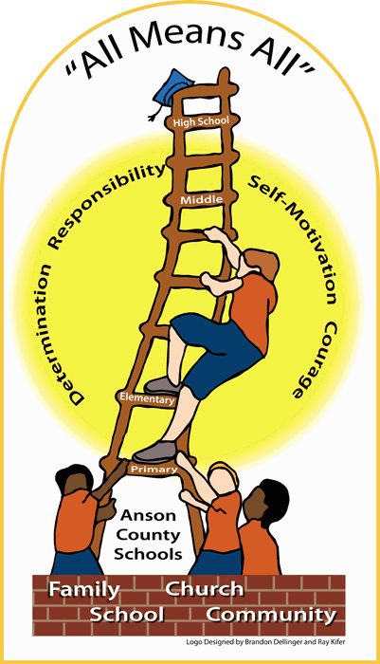**Anson County Schools**

**320 Camden Road, Wadesboro, NC 28170**

**Phone: 704-694-4417 Fax: 704-694-7479**

[www.ansonschools.org](http://www.ansonschools.org)

**Our Mission**

**"We will ensure that** all **studentsacquire skills and knowledge necessary**

**to be successful and responsible citizens."**

_______________________________________________________________________________________________________________

# Application for Need-Based Assistance

# 2020-2021 School Term

## Every school year, a variety of opportunities are available for students from families with limited financial resources. This data is being collected to assist as determinations are made pertaining to a student’s eligibility to have fees waived associated with various educational needs.

If your household income falls below the ranges specified below and you would like your child to be considered as these opportunities arise, please complete this form and return it to the Principal’s Office. Only students with a signed and completed form on file will be considered for these need- based opportunities.

**Special Note**: **This form must be updated annually to reflect the current household income levels designated by official government indexes.**

# I, am the parent or legal guardian of

Print Name of Parent

**.**

Print Name of Student

.

**Check the box below that best matches your household size and yearly income:**

D There are 2 people in our household and our yearly income is less than $31,894 (or less than $2,658 per month).

D There are 3 people in our household and our yearly income is less than $40,182 (or less than $3,349 per month).

D There are 4 people in our household and our yearly income is less than $48,470 (or less than $4,040 per month).

D There are 5 people in our household and our yearly income is less than $56,758 (or less than $4,730 per month).

D There are 6 people in our household and our yearly income is less than $65,046 (or less than $5,421 per month).

D There are 7 people in our household and our yearly income is less than $73,334 (or less than $6,112 per month).

D There are 8 people in our household and our yearly income is less than $81,622 (or less than $6,802 per month).

# Parent/Guardian Signature Date

-------------------------------------------------------------------------------------------------------------------------------------------------------

**School Use Only**

## Reviewed by

Approved by

Signature of School Staff Member

Signature of School Administrator

Denied by Signature of School Administrator